A project report on

College/Students Management System

Submitted to **Arcade Business College**- **Patna**

(**Affiliated to Patliputra University- Patna**)



In partial fulfillment for the award of degree of

**BACHELOR OF**

**COMPUTER APPLICATIONS**

Submitted by

**ALOK KUMAR**

(College Roll. No. : **18271**, University Roll. No. : **1943940080235**)

Session: 2018-2021

Guided by

**LOKANATH MAHANTA**

(Head of Department)

Arcade Business College- Patna

**March – 2021**



**Date: 05/03/2021**

**TO WHOMSOEVER IT MY CONCERN**

This is to certify that the Student Mr. Alok Kumar of Arcade Business College- Patna, has satisfactorily completed his/her Project on COLLEGE\STUDENTS MANAGEMENT SYSTEMduring the period December 2020 to March 2021 in the partial fulfilment of BCA PAPER VIII.

**Name & Signature of Project Guide: Signature & Seal of Principal:**

**Address:**

**Patna West : Patna East :**

Near Saguna More Arya Kumar Road

Khagaul Road Rajendra Nagar

(Opp. St. Karen's School) Patna, Bihar 800016 Patna Bihar 801503 Ph. (0612) 2666000, 2663335

Ph. 94316 29500, 94730 44410​ abcollege.patna@gmail.com

info@abcollege.org

**ACKNOWLEDGEMEN**

I take this occasion to thank God, almighty for blessing us with his grace and taking our endeavor to a successful culmination.

I would like to express my deep and sincere gratitude to my supervisor **Mr. Lokanath Mahanta**, Project Manager (Arcade Business College- Patna), who gave me his full support and encouraged me to work in an innovative and challenging project for Educational field. His wide knowledge and logical thinking gave me right direction all the time.

I extend my BCA thanks to our respected **Mrs. Akansha Mam**, for allowing us to use the facilities available.

I would like to thank the other faculty members also, at this occasion. Last but not the least, I Would like to thank my friends and family for the support and encouragement they have given me during the course of our work.

**ALOK KUMAR**

Saturday, March 06, 2021



**COMPLETION CERTIFICATE**

This is to certify that Mr. /Ms. **Alok** of Bachelor in (**Computer Applications**) from **Arcade Business College**  (Institute/University) was working on the project entitled “ College/Student Management System” in Arcade Business College . She/he was engaged with us from past 90 days.

She/He has done an excellent job during his/her engagement with the Application Development & I would like to take this opportunity to express my appreciation to Mr./Ms. **Alok Kumar** for his/her work and wish him/her all the very best for his/her future endeavors.

**Regards,**

Lokanath Mahanta

HOD

Arcade Business College.

Patna (Bihar.)

-----------------------------

**DECLARATION**

This is to certify that the project report entitled “College/Students Management System ” is done by me is an authentic work carried out for the partial fulfillment of the requirements for the award of the Bachelor in “(**Computer Applications**)” under the guidance of **Mr. Lokanath Mahanta**.

The matter embodied in this project work has not been submitted earlier for award of any degree or diploma to the best of my knowledge and belief.

**ALOK KUMAR**

**TABLE OF CONTENTS**

|  |  |  |
| --- | --- | --- |
| **Sr. No:** | **Contents** | **Page No:** |
| **1.** | **Introduction:**  1.1 Background  1.2 Objective  1.3 Purpose  1.4 Scope of System | **6** |
| **2.** | **Requirement And Analysis:** 2.1 Problem Definition  2.2 Requirement Specification 2.3 Hardware Requirement  2.4 Software Requirement  2.5 Planning Scheduling | 18 |
| **3.** | **System design:**  3.1 Data dictionary  3.2 Input & output design | 29 |
| **4.** | **Testing & Implementation:**  4.1 Testing approach used  4.2 Implementation Approaches | 41 |
| **5.** | **Conclusion**  5.1 Conclusion  5.2 Limitation Of System  5.3 Future Scope Of System 5.4 Bibliography | 46 |

**TITLE OF THE PROJECT**

**College/Students Management System** is an application project which is dedicated to all colleges that use the register to manage their data in this digital era. This application help colleges to manage their data easily & it saves lots of time. In this application we add several tools like Search record of student & faculty, Add or Delete record, etc.

In this application, the College management team can print details, Modify details, Delete or move the location of a particular student. The main focus of this application (project) is to Provide top-class services to students, So they do every activity for which they have to visit the management control room. So I took the suitable name of this project “**College/Students Management System**”.

**Chapter 1: Introduction**

Data is very important for any college; Everything like Student & faculty attendance, Library passes, Results, Contact details, Fee summary, and many more types of data are available in a college. To manage and find a particular record from the register is very tough. So, Therefore I create an application project using Visual Basic 6.0 & Oracle Database named “**College/Students Management System**” from which colleges can store data digitally in computer & Use or manage them very easily.

Visual Basic is a tool that is used by more number of developers than any other tool. Visual Basic has been the choice of developers for various good reasons. So many small and big companies use Visual Basic for developing various types of applications. One of the key factors that contributed to the success of Visual Basic is its ease of use. Where Oracle provides high securities at the database are stored in the logical area called “db Engine”.

Oracle Database 10g is the first database designed for enterprise grid computing, the most flexible and cost effective way to manage information and applications. Enterprise grid computing creates large pools of industry-standard, modular storage and servers. With this architecture, each new system can be rapidly provisioned from the pool of components.

|  |  |
| --- | --- |
| * 1. **Background** | |
| **Project Description** | It is a windows application. This program is created to maintain information about all the students, faculty in the colleges & it increases work potential as well as saves a lot of time for students and management. |
| **Project Duration** | 2 to 3 Month. |
| **Project Guide** | Lokanath Mahanta |
| **Platform** | Windows 7 Unlimited |
| **Processor:** | Intel(R) Core(TM) 13-2350M CPU @ 2.30GHZ 2.30 GHz |
| **System type & RAM** | 64-bit Operating System With 2.00 GB RAM |
| **Technologies Used** | Microsoft Visual Basic 6.0  Oracle Database 10g |
| **Tools Used** | Canva for graphics  Diagrams.net for Digram  EASendMail for SMPT |

* The aim of this system is to save time, money & manage data through computer Independence to manage data from anywhere at any time.
* Independence to manage data from anywhere at any time
* It was realized that several colleges are using the register to mention data, & it is very costly and time-consuming.
* I came up with a college/students management system that will end all this.
* Bring education to its standards in the digital world.

|  |
| --- |
| **1.2 Objective** |

* COLLEGE/STUDENTS MANAGEMENT SYSTEM is a computer application (Program) designed primarily for use in the data management for college and it also provides the facility for students to generate pass, check syllabus, etc.
* This system will allow colleges to increase the scope of business by reducing the labor cost & time.
* This system is designed for students of college, who have their own problems as well as time restrictions. It allows the admin to manage the users and to do other things like updating of report cards etc. The main advantage is that it is done in Visual Basic 6.0. Though Visual Basic isn't a popular language it does mean that anyone with knowledge of VB 6.0 can understand the project easily.
* The main point of developing this system is to help college administrators manage the college data and help students for tracking their information like notice, result, attendance.
* The system also allows to quickly and easily manage data which customers can browse and use to place orders with just a few clicks.
* Colleges/Schools Management System will be a host for the database to store student data (Student Id, Name, DOB, Gender, Emails etc.).
* Eliminate paper work and increase level of accuracy.
* Increase speed of service, students satisfaction.

|  |
| --- |
| **1.3 Purpose** |

This computer application enables the end-users to register, login & check their data like attendance, faculty name, subject, etc at a place.

By just selecting & open the application & have to login as a student.

The user will check the updates given by the admin. Admin can view Customer details and have permission to edit them

|  |
| --- |
| **1.4 Scope of System** |

**SYSTEM PROFILE:**

This college/student management application is committed to being the best in all areas of its design & reliability.

Data management system will be a computer application (Programe) whose main language of programming will be Visual basic 6.0 & Orcale 11g. Its main aim is to simplify and improve the efficiency of the data process for both student and management, minimize manual data entry and ensure data accuracy and security.

We aim to make a clean, simple and user-friendly application for the teachers, students and college staff. We want to provide a functionality that is easily usable and efficient.

**MODULES:**

**There are mainly two modules**

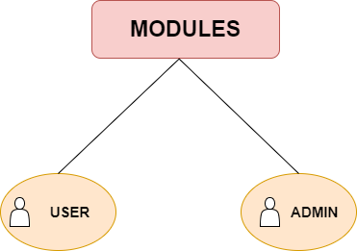

**MODULES FRONTEND:-**

Users can see the application interface first with a screen splash then after the new window open where login, contact, help, exit button, etc are available.

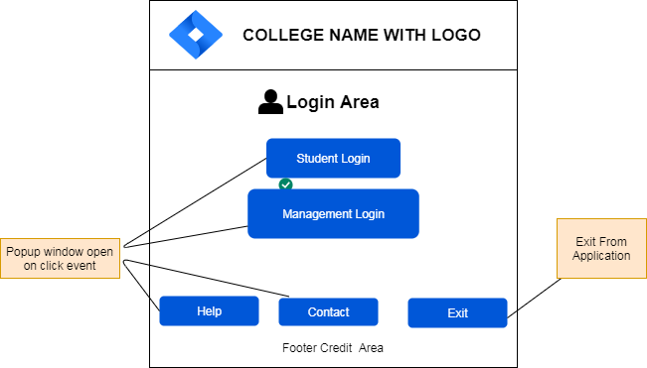

**SCREEN SPLASH:**

When the user will open the application (Program) screen splash occurs where you can find a progress bar with a 5-second timer & some information like application version, developer name, logo, etc.

**Reference Diagram of Slash Screen**

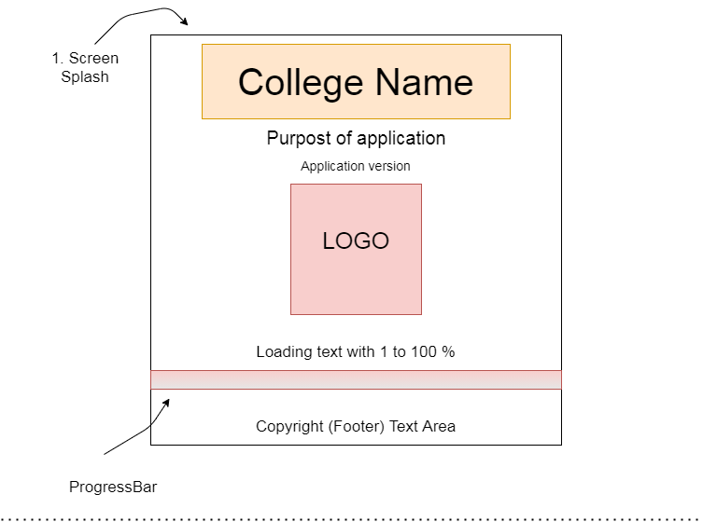

**LOGIN FORM:**

By pressing the login button a popup occurs where the user can log in with a username and password. If they forget their password, they can reset it very easily with forget button available on the popup window.

**Reference Diagram of Login Form**

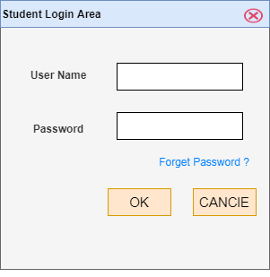

**CONTACT FORM:**

By pressing the contact button a popup occurs where the user can send message to management. There is a form box-like name, email, roll no, etc. Users can fill form and submit through send button or cancle popup window by clicking on cancle button. By clicking on send button all information went to college email id vai EASendMail . EASendMail Service is a light and fast email delivery service which works with EASendMail SMTP .Net Component / ANSMTP SMTP Component to enable your application to send mass emails in background service.

**Reference Diagram of Contact Form**

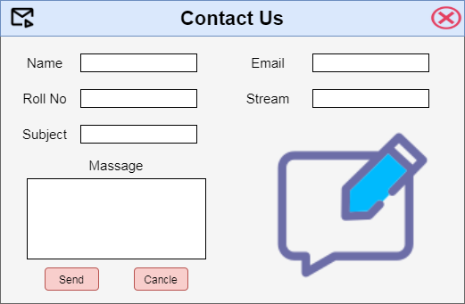

**HELP CENTER:**

By clicking the help button a popup occurs where the user can get general help resources like how to register, how to use the application etc. To create this screen, I just took a dialog box & use a label, command button & an Image to give good look. By the use of massage box & a component named Microsoft Internet Controls to display webpage.

**Reference Diagram of Help Center**

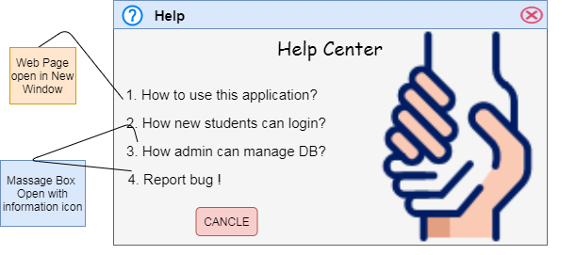

**SCOPE:**

Scope and Limitation for College/Students Management System are still using a manual procedure in keeping records of their Students and Faculty data, current and upcoming. To gather information the administrator must fill-up all student data through their dashboard.

This type of process best applies to new students only since they have not their login details.

Chapter 2: Requirement and Analysis

|  |
| --- |
| 2.1 Problem definition |

* The existing system is manual system.
* The existing process of data is on paper (Hard Copy).
* Needs to be converted into automated system & the process of data is paperless (Soft Copy).
* As it has a risk of mismanagement of data, less Security, no proper coordination between direct applications and users, fewer users - friendly, accuracy not guaranteed and not in reach of distant users.
* In the existing system, humans performed all the tasks. As in the human tendency, error is also a possibility. Therefore, the inputs entered by the person who is working in the college, in the registers may not be absolutely foolproof and may be erroneous. As a result of wrong input, the output reports etc. Will also be wrong which would in turn affect the performance.
* Securityconcerns were also one of the motives of the college for the need of software. In the registers, the data is not secure as anybody can tamper with the data written in the registers. While in this software, just a password makes it absolutely secure from the reach of unauthorized persons.
* In manual system maintaining a register and performing the necessary calculation has proved to be a troublesome job, which takes a lot of time and may affect the performance of the college. But with this software we can have all the tasks performed in a fraction of second by a single click thus making the troublesome job much easier
* When a number of tough tasks are prepared by the humans like preparation of reports, performing long calculation then some human error are obvious due to a number of factors like mental strain, tiredness etc. But as we all know that computer never get tired irrespective of the amount of work it has to do. So this software can nullify the probability of manual error that improve the performance.
* In manual system whenever a record is to be updated or to be deleted a lot of cutting and overwriting needs to be done on the registers that are concerned that are deleted or updated record, which makes the work very complex.

**EXISTING SYSTEM DESCRIPTION**

The existing system College is to manage the relationship with User members by storing the user data in registers. The existing system has following drawbacks:

* Time Consuming
* Manual Errors
* Complexity
* Low Security
* Data Redundancy
* Portability
* No more helpful to improve college business

|  |
| --- |
| 2.2 Requirement Specification |

* A system’s requirement analysis is an important component of the system development process.
* This perhaps the most important and essential ingredient of the system analysis phase and its proper completion ensures the success of the entire system.
* It establishes what the new system must do, it involves identifying who needs what information, where, when and how.
* It also identifies the data, process and interface requirements for the users of the new system.
* Errors and omissions in requirement analysis result in user dissatisfaction with the final system and it will force to be highly cost and incur heavily loss.
* The ultimate goal of the requirement analysis is the creation of the requirement specification for the new system.

**Functional Requirement**

* The only requirement is to automate the whole system as a good source of providing the reliable information to that the user so that they can get the maximum benefit of the services provided by the college.

**Non-functional Requirement**

The supplementary specification applies to college/students management system. This specification defines the non-functional requirement of the system such as:

* **Functionality**

Since it is a computer application, one or more user may use it at a time using the their specific login details.

* **Usability**

A window operating system running the latest version of the OS.

* **Reliability**

The system is run only on window operating system. It is not working for Linux, Mac OS or any other operating system. It also need good internet connection to use some feature of programe.

* **Performance**

The performance depends on hardware specification of the Operating System & uses task manager.

|  |
| --- |
| **2.3 Hardware Requirements** |

* Window Operating System (Above Version XP)
* RAM 1.00 GB or above
* Processor i3 or above
* A Graphic card for smooth performance (Not Important)

|  |
| --- |
| **2.4 Software Requirements** |

**Frontend Technology**

* MICROSOFT VISUAL BASIC 6.0

**Backend tools**

* ORACLE 10G

|  |
| --- |
| **2.5 Planning Scheduling** |

**Software Project Planning**

Goal is to establish a pragmatic strategy for controlling, tracking, and monitoring a complex technical project

**Must deal with**

* Project complexity: has a strong effect but is heavily influenced by past practitioner experience.
* Project size: as size increases the interdependency of elements also grows.
* The degree of structural uncertainty: the degree to which requirements are solidified and the ease of functional decomposition.
* The purpose of project planning is to ensure that the end result is completed on time, within budget, and exhibits quality!

**Project Planning**

The main focus of the project was to create a working “College/Student” management system that acts as both a terminal for taking data form from the administrator, the admins have more power than students and another terminal for students, from where they can check their activity & do some changes but in limitation.

Project planning was done to define the scope of the project, assess risks, and estimate and schedule project activities and thereby lay the foundation for the execution, monitoring and control of the project.

**Study of the Problem**

The database is critical to set up for students and admins both for first time, It is a protable window OS application so only windows OS users can take benefits from this project. This is a small scale project for colleges.

**USER ROLE:**

The customers can login/logout the System. He /She can view his/her details like attendance, Faculty details etc.

**Scheduling**

The project scheduling is a mechanism to communicate what tasks need to get done and which organizational resources will be allocated complete those tasks in what timeframe. A project scheduling is a document collecting all the work needed to deliver the project on time.

|  |
| --- |
| **Spiral Model** |

**Spiral model** is one of the most important Software Development Life Cycle models, which provides support for **Risk Handling**. In its diagrammatic representation, it looks like a spiral with many loops. The exact number of loops of the spiral is unknown and can vary from project to project. Each loop of the spiral is called a **Phase of the software development process.**

**Spiral Model – Design**

The spiral model has four phases. A software project repeatedly passes through these phases in iterations called Spirals

* **Identification**

This phase starts with gathering the business requirements in the baseline spiral. In the subsequent spirals as the product matures, identification of system requirements, subsystem requirements and unit requirements are all done in this phase.

This phase also includes understanding the system requirements by continuous communication between the customer and the system analyst. At the end of the spiral, the product is deployed in the identified market.

* **Design**

The Design phase starts with the conceptual design in the baseline spiral and involves architectural design, logical design of modules, physical product design and the final design in the subsequent spirals.

* **Construct or Build**

The Construct phase refers to production of the actual software product at every spiral. In the baseline spiral, when the product is just thought of and the design is being developed a POC (Proof of Concept) is developed in this phase to get user feedback.

Then in the subsequent spirals with higher clarity on requirements and design details a working model of the software called build is produced with a version number. These builds are sent to the user for feedback.

* **Evaluation and Risk Analysis**

Risk Analysis includes identifying, estimating and monitoring the technical feasibility and management risks, such as schedule slippage and cost overrun. After testing the build, at the end of first iteration, the customer evaluates the software and provides feedback.

The most important feature of the spiral model is handling these unknown risks after the project has started. Such risk resolutions are easier done by developing a prototype. The spiral model supports coping up with risks by providing the scope to build a prototype at every phase of the software development.

The following illustration is a representation of the Spiral Model, listing the activities in each phase.

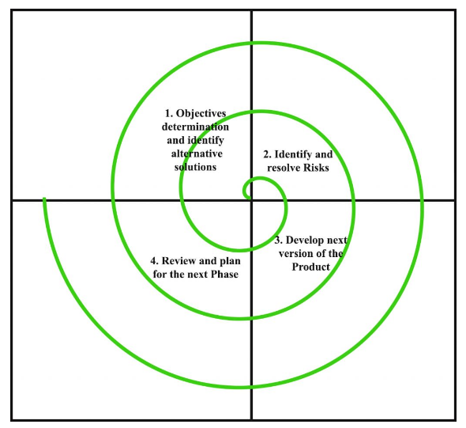

Image Credit: Geeksforgeeks

Spiral Model Application

The Spiral Model is widely used in the software industry as it is in sync with the natural development process of any product, i.e. learning with maturity which involves minimum risk for the customer as well as the development firms.

**Chapter 3 : System Design**

|  |
| --- |
| **Data flow diagram (DFD)** |

Data flow diagram shows the way information flows through a process or system. It includes data inputs and outputs, data stores, and the various sub processes the data moves through. DFDs are built using standardized symbols and notation to describe various entities and their relationships

Data flow diagrams visually represent systems and processes that would be hard to describe in a chunk of text. You can use these diagrams to map out an existing system and make it better or to plan out a new system for implementation. Visualizing each element makes it easy to identify inefficiencies and produce the best possible system.

**Uses of DFD:-**

The main uses of data flow diagrams are as follows:-

DFD is a method of choice for representation of showing of information through a system because of the following reasons:-

* DFDs are easier to understand by technical and non-technical audiences.
* DFDs can provide high level system overview, complete with boundaries and connections to other system.
* DFDs can provide a detailed representation of system components.

**Symbol of DFD**

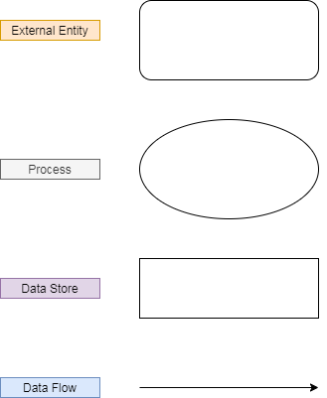

**Data flow diagram levels**

**Level-0 DFD**

Also known as context diagrams, are the most basic data flow diagrams. They provide a broad view that is easily digestible but offers little detail.

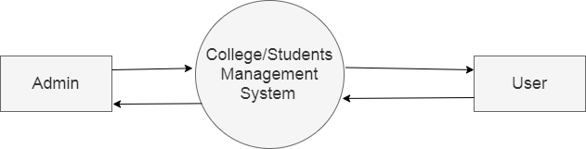

**[System: 0 level DFD**

**Level-1:-**

Level 1 DFDs are still a general overview, but they go into more detail than a context diagram. In a level 1 data flow diagram, the single process node from the context diagram is broken down into sub processes. As these processes are added, the diagram will need additional data flows and data stores to link them together.

**Level-1 User & Admin Diagram**

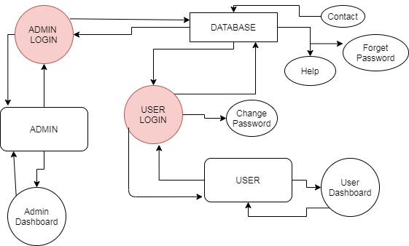

**Level-1 Admin dashboard:**

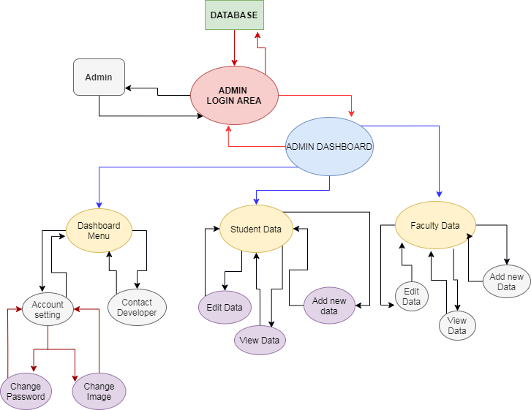

**Level-1 User dashboard:**

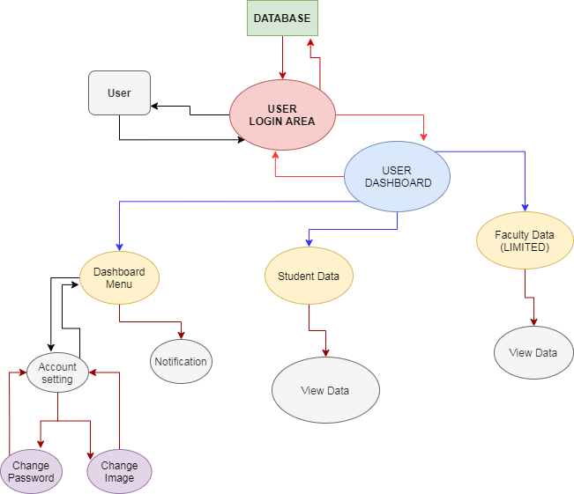

**2nd Level DFD :Admin Dashboard**

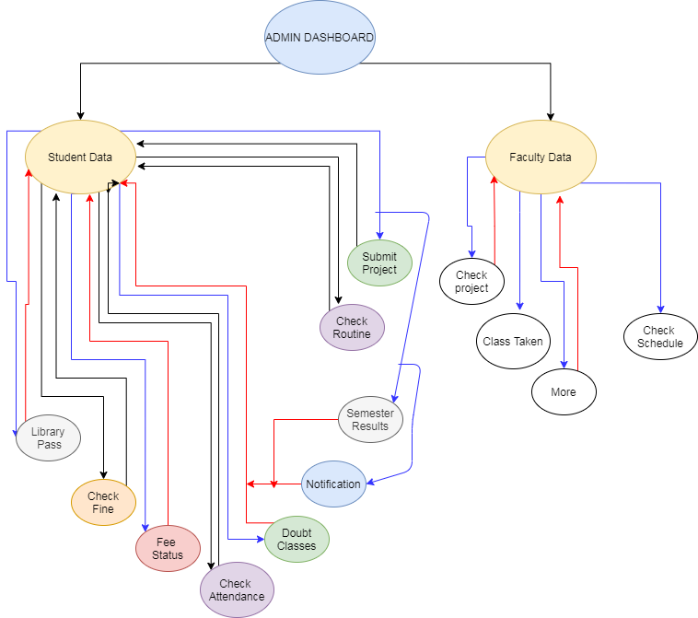

**2nd Level DFD :User Dashboard**

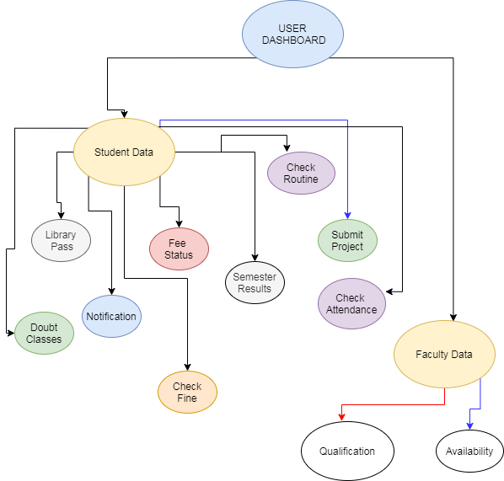

|  |
| --- |
| **E-R Diagram** |

Entity Relationship Diagram, also known as ERD, ER Diagram or ER model, is a type of structural diagram for use in database design. An ERD contains different symbols and connectors that visualize two important information. The major entities within the system scope, and the inter-relationships among these entities.

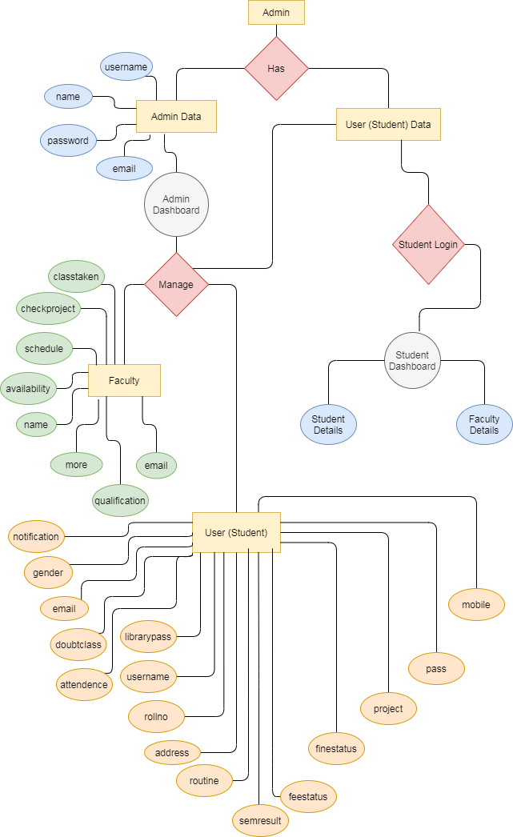

**Table : user_data**

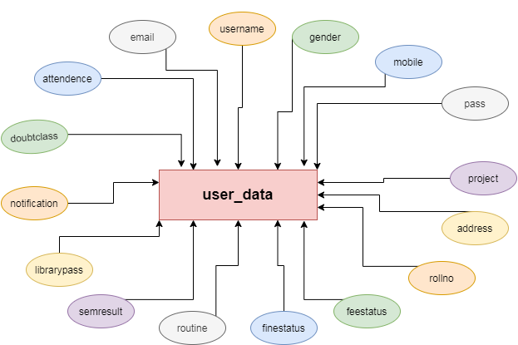

**Table : faculty_data**

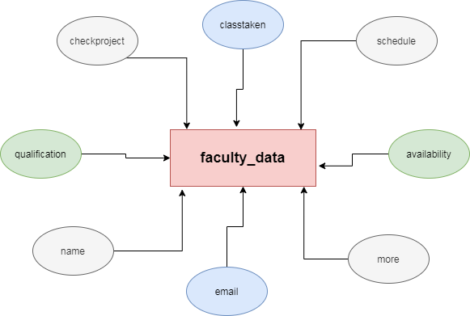

**Table : admin_data**

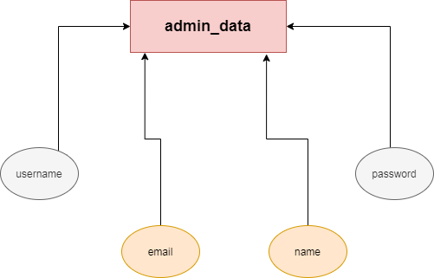

|  |
| --- |
| **Data dictionary** |

**[Table: user_data]**

|  |  |  |  |  |  |
| --- | --- | --- | --- | --- | --- |
| **Table No:** | | | **1** | | |
| **Table Name:** | | | **user_data** | | |
| **Seq. no** | **Column Name** | **Size** | **Column type** | **Column description** | **Pk/fk** |
| 1 | id | 11 | bigint | Auto increment | Primary Key |
| 2 | username | 25 | varchar | Student Username |  |
| 3 | gender | 6 | varchar | Student Gender |  |
| 4 | mobile | 10 | varchar | Student Mobile no |  |
| 5 | pass | 255 | varchar | Student Login Password |  |
| 6 | project | 255 | varchar | Submit Project |  |
| 7 | address | 255 | varchar | Student Address |  |
| 8 | rollno | 11 | bigint | Student Roll no. |  |
| 9 | feestatus | 25 | varchar | Fee Status |  |
| 10 | finestatus | 10 | varchar | Fine Status |  |
| 11 | routine | 255 | varchar | Student college Routine |  |
| 12 | semresult | 255 | varchar | Semester Result |  |
| 13 | librarypass | 255 | varchar | Student Library Pass |  |
| 14 | notification | 255 | varchar | Notification |  |
| 15 | doubtclass | 255 | varchar | Doubt Class Schedule |  |
| 16 | attendence | 5 | int | Student Attendence |  |
| 17 | email | 255 | varchar | Student Email |  |

**[Table: faculty_data]**

|  |  |  |  |  |  |
| --- | --- | --- | --- | --- | --- |
| **Table No:** | | | **1** | | |
| **Table Name:** | | | **faculty_data** | | |
| **Seq. no** | **Column Name** | **Size** | **Column type** | **Column description** | **Pk/fk** |
| 1 | id | 11 | bigint | Auto increment | Primary Key |
| 2 | classtaken | 3 | int | Faculty Class Taken Record |  |
| 3 | schedule | 255 | varchar | Faculty Schedule |  |
| 4 | availability | 25 | varchar | Faculty Availability |  |
| 5 | more | 255 | varchar | More on Faculty |  |
| 6 | email | 255 | varchar | Faculty Email |  |
| 7 | name | 75 | varchar | Faculty Name |  |
| 8 | qualification | 255 | varchar | Faculty Qualification |  |
| 9 | checkproject | 255 | varchar | Faculty Project Request |  |

**[Table: admin_data]**

|  |  |  |  |  |  |  |
| --- | --- | --- | --- | --- | --- | --- |
| **Table No:** | | | | **1** | | |
| **Table Name:** | | | | **admin_data** | | |
| **Seq. no** | **Column Name** | | **Size** | **Column type** | **Column description** | **Pk/fk** |
| 1 | id | 11 | | bigint | Auto increment | Primary Key |
| 2 | name | 75 | | varchar | Admin Name |  |
| 3 | username | 25 | | varchar | Admin Username |  |
| 4 | email | 255 | | varchar | Admin Email |  |
| 5 | password | 255 | | varchar | Admin Password |  |

**Chapter 4: Testing & Implementation**

|  |
| --- |
| **4.1 Testing approach used** |

**Black box testing:**

Testing, either functional or non-functional, without reference to the internal structure of the component or system.

Black Box, also known as Behavioral Testing, is a software testing methods in which the internal structure/design/implementation of the item being tested is not known to the tester. These tests can be functional or non-functional, though usually functional.

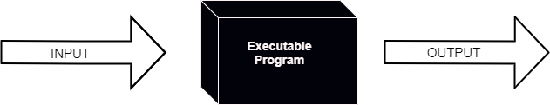

This method is named so because the software program, in the eyes of the tester, is like a black box; inside which one cannot see.

* This method attempts to find errors in the following categories:
* Incorrect or missing functions
* Interface errors
* Errors in data structures or external database access
* Behavior or performance errors
* Initialization and termination errors.

|  |
| --- |
| **White Box Testing** |

White Box Testing (also known as Clear Box Testing, Open Box Testing, Glass Box Testing, Transparent Box Testing, Code-Based Testing or Structural Testing) is a software testing method in which the internal structure/design/implementation of the item being tested is known to the tester. The tester chooses inputs to exercise paths through the code and determines the appropriate outputs. Programming know-how and the implementation knowledge is essential. White box testing is testing beyond the user interface and into the nitty-gritty of a system.

This method is named so because the software program, in the eyes of the tester, is like a white/transparent box; inside which one clearly sees.

**Advantages:**

* Testing can be commenced at an earlier stage. One need not wait for the GUI to be available.
* Testing is more thorough, with the possibility of covering most paths.

**Disadvantages**

* Since tests can be very complex, highly skilled resources are required, with a thorough knowledge of programming and implementation.
* Test script maintenance can be a burden if the implementation changes too frequently.
* Since this method of testing is closely tied to the application being tested, tools to cater to every kind of implementation/platform may not be readily available.

|  |
| --- |
| **Grey Box Testing** |

Grey Box testing is testing technique performed with limited information about the internal functionality of the system. Grey Box testers have access to the detailed design documents along with information about requirements.

Grey Box tests are generated based on the state-based models, UML Diagrams or architecture diagrams of the target system.

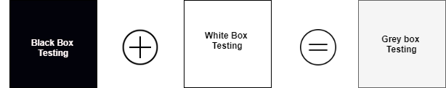

**Grey-box testing Techniques:**

* Regression testing
* Pattern Testing
* Orthogonal array testing
* Matrix testing

**Benefits:**

* Grey-box testing provides combined benefits of both white-box and black-box testing.
* It is based on functional specification, UML Diagrams, Database Diagrams or architectural view.
* Grey-box tester handles can design complex test scenario more intelligently.
* The added advantage of grey-box testing is that it maintains the boundary between independent testers and developers.

**Drawbacks:**

* In grey-box testing, complete white box testing cannot be done due to inaccessible source code/binaries.
* It is difficult to associate defects when we perform Grey-box testing for a distributed system.

**Chapter 5: Conclusion**

|  |
| --- |
| **5.1 Conclusion** |

Finally in college/students management system, we have a system where a student who check there activity according to the choice of type of account details, fee status, attendence, routine, notification, faculty details, etc and they can also submit their project and apply for doubt class very easily at one place.

Admin check & modify student & faculty data very easily, And all this work done without paper or pen. The data is now on soft copy mode . So it all working fine.

|  |
| --- |
| **5.2 Limitations** |

* Need Internet Connection for perfect working
* You must have pc/laptop.
* It works only on windows OS
* Limited area covered
* Security

|  |
| --- |
| **5.3 Future Scope of System** |

* Nothing is perfect in this world. So, we are also no exception. Although, we have tried our best to present the information effectively, yet, there can be further enhancement in the Application
* We have taken care of all the critical aspects, which need to take care of during the development of the Project.
* Like the things this project also has some limitations and can further be enhances bysomeone, because there are certain drawbacks that do not permit the system to be 100% accurate.

**Some key Feature we can add in This System Like:**

We can provide facilities like faculty login, student registration and faculty registration.

|  |
| --- |
| **5.4 Bibliography** |

<https://www.diagrams.net/>

<https://www.geeksforgeeks.org/>

<https://www.canva.com/>

<https://www.emailarchitect.net/easendmail>